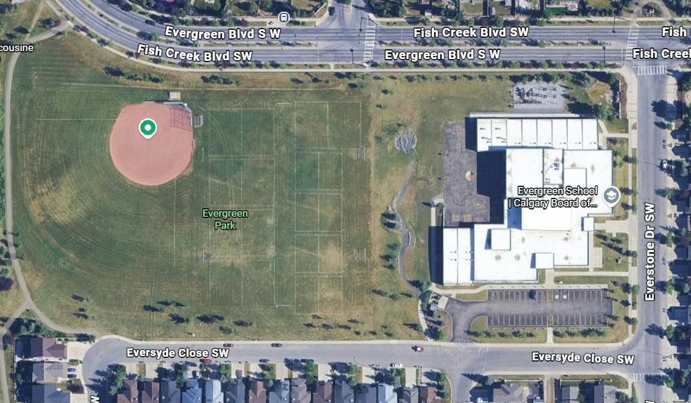
Grade 5
Grade 1
Grade 4
Kindergarten and EES to follow Staggered Entry schedules received via e-mail.
Grade 3
Grade 2

